ABSTRACT
The Library Management System is a web-based platform developed to automate and simplify the daily operations of a library. Managing large numbers of books and users manually often leads to errors, data inconsistency, and time delays. This system aims to overcome those challenges by creating an efficient and reliable solution that handles book issuance, renewal, return, fine calculation, and catalog management through a centralized digital process.
The system provides role-based access for Librarians, Students, and Faculty, ensuring that each user interacts only with relevant features. Librarians can add and update books, view issued records, manage fine collection, and handle user queries, while students and faculty can easily search for books, check availability, issue or renew them online, and track their borrowing history. The system also includes features like feedback submission, automatic fine alerts, and a user-friendly dashboard for quick navigation and better interaction.
Developed using HTML, CSS, PHP, and MySQL, the system follows standard software engineering principles, including requirement analysis, design, implementation, and testing. It ensures scalability, security, and accuracy in handling data. By digitizing the complete library process, the system not only saves time and effort but also enhances transparency, accessibility, and overall user satisfaction. This project demonstrates how technology can transform traditional manual operations into a smart, efficient, and well-managed digital library environment.

CHAPTER 1
INTRODUCTION
1.1 OVERVIEW
A library serves as an essential component of any educational institution, acting as a central hub for knowledge acquisition, research, and academic growth. However, managing extensive collections of books, journals, magazines, and user information through manual methods is both time-consuming and prone to human error. Tasks such as issuing and returning books, maintaining records, and calculating overdue fines often become tedious, leading to inefficiencies in day-to-day library operations.
To overcome these challenges, the Library Management System (LMS) has been developed to automate and streamline all major library processes. The system provides a comprehensive solution for managing book catalogues, tracking transactions, and maintaining user records efficiently. It ensures accuracy, transparency, and ease of access for both administrators and library members.
The proposed Library Management System is a web-based application that modernizes the functioning of a traditional library by integrating digital tools and automation techniques. It allows librarians to perform administrative operations such as managing users, updating book inventories, issuing and returning books, and calculating fines automatically. Meanwhile, students and faculty can easily search for books, check their availability, submit issue or renewal requests, and monitor their borrowing history from any connected device.
The primary objective of this system is to minimize manual intervention, reduce human errors, and enhance operational efficiency. Furthermore, it provides real-time information access, enabling users to interact seamlessly with the library’s digital resources. By integrating technology into library management, the system contributes to a more organized, user-friendly, and efficient academic environment.

1.2 BACKGROUND
In earlier times, libraries operated using traditional, manual methods of management, relying heavily on physical registers, logbooks, and handwritten records. Librarians were required to maintain detailed ledgers for book entries, member details, issue and return records, and overdue fines. While effective to some extent, these manual processes were time-consuming, error-prone, and inefficient—especially as library collections and user bases grew. Misplaced records, duplicate entries, and delays in locating books or calculating fines were common issues that hampered smooth library operations.
The rapid growth of information technology has revolutionized the way data is stored, accessed, and managed. Modern educational institutions are increasingly adopting computerized systems to replace traditional workflows. Libraries, being vital centers of learning and info, have also begun
transitioning toward digital management systems that ensure accuracy, transparency, and easy access to information.
A Library Management System (LMS) integrates technology into traditional library operations by automating core functions such as cataloging, circulation, fine calculation, and report generation. It allows librarians to efficiently handle large volumes of books and user data, reducing paperwork and manual errors. Moreover, it empowers students and faculty by providing convenient features such as online book searches, availability checks, renewal requests, and notifications.
The implementation of a digital LMS not only enhances operational efficiency but also contributes to better resource utilization and user satisfaction. By transforming conventional library management into a streamlined and interactive system, institutions can create a more organized, time-saving, and user-friendly environment that aligns with the needs of today’s digital learners.

1.3 PROBLEM DEFINITION
In most educational institutions, library operations are still managed through manual processes involving handwritten records, paper-based book logs, and physical files. This traditional approach creates several challenges in efficiently managing the increasing number of books, members, and daily transactions. The manual recording of book issues and returns often leads to inaccuracies, misplaced data, and delays in tracking borrowed items. Moreover, calculating overdue fines and updating inventory records manually increases the risk of human errors.
Students and faculty members also face difficulties when searching for books or checking their availability, as such tasks require physical visits to the library and manual catalog checks. This not only consumes valuable time but also reduces the overall user experience. Additionally, the lack of real-time data access prevents librarians from generating timely reports and managing library resources effectively.
Therefore, there is a clear need for a computerized Library Management System (LMS) that automates and streamlines library functions. The proposed system aims to eliminate the inefficiencies of manual methods by providing digital solutions for catalog management, user registration, book issuance, returns, renewals, and fine calculation. It will also offer role-based access control to ensure secure operations—allowing librarians to manage resources and users efficiently, while enabling students and faculty to search and borrow books online with ease.
By addressing these issues, the Library Management System seeks to enhance accuracy, speed, transparency, and accessibility in all library-related activities, thereby improving both administrative productivity and user satisfaction.

1.4 OBJECTIVES
The main objective of the Library Management System (LMS) is to design and implement an efficient, automated solution that simplifies and modernizes the management of library operations. The system aims to minimize human effort, reduce manual errors, and improve the accessibility of library resources for students, faculty, and librarians.
The specific objectives of the system are as follows:
- Automation of Library Operations:
To automate core functions such as book issuance, return, renewal, and fine calculation, thereby reducing the dependency on manual record-keeping.
- Efficient Catalog Management:
To maintain a structured and searchable database of all books, including details like title, author, genre, publication, and availability status.
- Role-Based Access Control:
To provide different levels of access and privileges for librarians, students, and faculty, ensuring security and proper management of data.
- User-Friendly Interface:
To develop an intuitive and easy-to-navigate web interface that allows users to perform tasks such as searching for books, checking availability, and managing their accounts.
- Accurate Fine Calculation and Reporting:
To implement a transparent and automated fine calculation mechanism for overdue books and generate detailed reports for administrative review.
- Real-Time Data Access:
To enable librarians and users to view up-to-date information about book availability, issue status, and user activity.
- Scalability and Maintainability:
To design the system in a modular manner so it can be easily expanded or integrated with other institutional systems in the future.

1.5 SCOPE OF THE PROJECT
The Library Management System (LMS) is designed to automate and streamline all major activities of a library within an educational institution. The scope of this project encompasses the complete digital transformation of traditional library operations, ensuring improved efficiency, transparency, and user satisfaction.
The system will allow librarians to manage books, users, and transactions through an easy-to-use web interface. They can add, update, or remove books from the catalog, manage user accounts, issue or return books, and monitor overdue items. Automated fine calculation ensures that penalties for late returns are computed accurately, eliminating manual errors.
For students and faculty, the system provides convenient access to search and reserve books, check availability, view their borrowing history, and renew books online. This minimizes the need for physical visits to the library for basic operations, thereby saving time and improving accessibility.
The system’s architecture supports multiple user roles and ensures secure access to data through authentication and authorization mechanisms. The database-driven backend maintains records of books, users, and transactions in a centralized and organized manner.
However, the current scope of the project primarily focuses on core library functionalities such as book management, user management, and transaction tracking. Advanced features like online e-book integration, digital payment for fines, and analytics dashboards can be incorporated in future enhancements.
In summary, this project provides a robust, scalable, and efficient solution for managing library activities, replacing manual workflows with a reliable automated system that benefits both library staff and users.

CHAPTER 2
LITERATURE REVIEW

The evolution of library management systems has been closely linked with advancements in information technology. Traditionally, libraries maintained manual registers to record the issuance and return of books. However, as the volume of library resources and users increased, manual systems became inefficient and error-prone. This led to the adoption of computerized systems that could automate daily operations and improve data accuracy.

Early studies on library automation focused primarily on database management and cataloging. Systems such as the Integrated Library System (ILS) were developed to manage bibliographic data using structured databases. These systems introduced the concept of centralized storage, allowing librarians to maintain and retrieve information more effectively. Over time, enhancements were made to include user management, fine tracking, and inventory control, making them more comprehensive.

Recent research has explored web-based and cloud-based solutions to improve accessibility and scalability. Web technologies like HTML, CSS, JavaScript, PHP, and MySQL have enabled the creation of interactive and user-friendly interfaces that can be accessed from anywhere, providing real-time information to users. Modern systems also incorporate role-based access control (RBAC) to ensure data security by assigning specific privileges to librarians, faculty, and students.

Some advanced systems integrate data analytics and machine learning algorithms to predict user preferences, recommend books, and optimize resource utilization. Mobile integration and e-book access are also gaining popularity, offering flexibility and convenience to modern users.
In conclusion, the literature highlights a continuous transition from manual record-keeping to intelligent, automated systems. The proposed Library Management System builds upon these advancements by integrating automation, accessibility, and real-time data management into a single platform, designed to meet the academic needs of students, faculty, and librarians effectively.

CHAPTER 3
SYSTEM ANALYSIS
3.1 Introduction
System Analysis is one of the most critical phases in the Software Development Life Cycle (SDLC), as it serves as the foundation for understanding the problem domain and designing an appropriate solution. It involves studying the existing system, identifying its limitations, and defining the specific requirements for the proposed system.
In the context of the Library Management System (LMS), system analysis focuses on evaluating the current manual operations of the library—such as book issuance, return, record maintenance, and fine calculation—and determining how these can be effectively automated. The goal is to develop a web-based solution that minimizes human intervention, reduces errors, and enhances the efficiency of library management.
This phase also involves a feasibility study to ensure that the proposed system is practical in terms of technology, operation, and cost. It defines both functional and non-functional requirements to guide the system’s development and ensure that it meets user expectations.
Ultimately, the outcome of system analysis is a clear understanding of what the system should do and how it should perform, providing a solid foundation for the next phase System Design.

3.2 Existing System
The existing library management process in most educational institutions is largely manual and relies on traditional methods of record-keeping. Librarians maintain handwritten registers or spreadsheets to record information about books, members, and transactions. Every time a student or faculty member borrows or returns a book, entries must be made manually, which is both time-consuming and prone to errors.
In this manual system, checking book availability requires physically searching through shelves or registers, and calculating fines for overdue books involves manual date comparison. This often leads to delays, inaccuracies, and inefficiencies in day-to-day operations. Moreover, generating reports, such as lists of issued books or overdue items, becomes a tedious and error-prone process.
Limitations of the Existing System:
- High risk of human error: Manual entry and calculations often result in mistakes.
- Time-consuming operations: Every transaction requires physical verification and recording.
- Data inconsistency: Difficulty in maintaining updated and synchronized records.
- Limited accessibility: Students and faculty must visit the library to perform simple tasks like book search or renewal.
- Lack of transparency: Tracking overdue books and fines is cumbersome.
- No data backup: Physical records are vulnerable to loss or damage.
Thus, the manual system is inefficient for managing large collections and handling multiple users simultaneously. The need for an automated, centralized, and user-friendly system is evident to improve operational efficiency, accuracy, and accessibility.

3.3 Proposed System
The proposed Library Management System (LMS) is a web-based automated solution designed to overcome the challenges of the existing manual library system. It provides a digital platform that simplifies and streamlines all major library operations such as book cataloging, issuance, return, fine calculation, and user management.
The system allows librarians to efficiently manage books and user data through a centralized database, while students and faculty can access library services online anytime and anywhere. The proposed system ensures accuracy, efficiency, and transparency in all transactions, significantly reducing manual workload and human errors.

Features of the Proposed System:
- Automated Transactions: The system automates book issuance, renewal, return, and fine calculation, eliminating manual record-keeping.
- Centralized Database: All book and user data are stored in a single, well-organized MySQL database that ensures consistency and easy retrieval.
- Search Functionality: Users can search books by title, author, genre, or publication using a fast, dynamic search interface.
- Role-Based Access: Different user roles—Librarian, Student, and Faculty—are defined to ensure secure and appropriate access to system functionalities.
- Real-Time Data Access: Both users and librarians can view live updates on book availability, issued books, and overdue items.
- Fine Calculation and Alerts : The system automatically calculates fines for overdue books and can notify users accordingly.
- Report Generation: Librarians can generate detailed reports on library activity, such as the number of books issued, overdue returns, and user history.
Advantages of the Proposed System:
- Increases efficiency and reduces human workload.
- Enhances user convenience and accessibility.
- Provides accurate, real-time information.
- Reduces paperwork and storage requirements.
- Improves transparency and accountability.
- Ensures better management and utilization of library resources.
In summary, the proposed Library Management System replaces manual operations with an intelligent, automated solution that benefits both librarians and users. It serves as a robust, scalable, and secure platform for efficient library management in modern educational institutions.

3.4 Feasibility Study
A feasibility study is conducted to determine the practicality and viability of developing the proposed Library Management System (LMS). It evaluates whether the system can be successfully designed, implemented, and maintained within the given constraints of technology, time, and cost. The study focuses on three major aspects: technical, operational, and economic feasibility.

3.4.1 Technical Feasibility
Technical feasibility evaluates whether the existing technology and infrastructure can support the development and deployment of the system.
The proposed Library Management System is developed using open-source technologies such as HTML, CSS, JavaScript, PHP, and MySQL, all of which are widely available, cost-effective, and compatible with various platforms. The system can be hosted on any standard web server, and users can access it through a web browser without installing additional software.
Since these technologies are well-documented and widely supported, development and maintenance are both practical and sustainable. Therefore, the project is technically feasible.

3.4.2 Operational Feasibility
Operational feasibility assesses whether the system will function effectively in the user environment and whether users will accept and adopt it.
The proposed LMS is designed with a user-friendly interface that minimizes the learning curve for librarians, students, and faculty. The automation of repetitive tasks such as book issuance, return, and fine calculation significantly reduces workload and manual errors. Librarians can manage operations more efficiently, while users can easily search for and access books online.
Since the system directly addresses the shortcomings of the existing manual process and improves user convenience, it is operationally feasible.

3.4.3 Economic Feasibility
Economic feasibility determines whether the project is financially viable in terms of cost-benefit analysis.
The system is developed using open-source software tools, which reduces licensing and implementation costs. The hardware requirements are minimal, as it runs on existing computer systems and networks within the institution. Over time, the system saves costs by reducing paperwork, eliminating manual record-keeping, and minimizing administrative overhead.
The long-term benefits of improved efficiency, accuracy, and time savings far outweigh the initial setup cost, making the system economically feasible.

3.4.4 Overall Feasibility Conclusion
After analyzing the technical, operational, and economic aspects, it is concluded that the proposed Library Management System is feasible for implementation. The use of reliable and cost-effective technologies, combined with improved efficiency and accessibility, ensures that the system will meet institutional requirements and provide lasting value.

3.5 Functional Requirements
Functional requirements define the specific behaviors, actions, and functionalities that the Library Management System (LMS) must perform. These requirements describe how the system should respond to user inputs and interactions, ensuring that it fulfills all the needs of librarians, students, and faculty members effectively.
The proposed system will include the following major functional requirements:

1. User Authentication and Role Management
- The system must allow users (Librarian, Student, and Faculty) to log in using valid credentials.
- Role-based access should restrict users from accessing unauthorized functionalities.
  - Librarian: Full administrative access to manage books and users.
  - Student/Faculty: Limited access to search, borrow, and view book history.

2. Book Management
- The librarian should be able to add new books to the catalog with details such as title, author, ISBN, genre, and quantity.
- The librarian should be able to edit or delete book information when necessary.
- The system should display real-time book availability status.

3. User Management
- The librarian should be able to register, update, or remove users (students or faculty).
- Each user must have a unique ID and personal details stored in the database.
- The system should maintain borrowing history for each user.

4. Book Issue and Return
- Librarian should be able to issue books to registered users and record issue dates.
- Upon return, the system should automatically update book availability and calculate fines (if any).
- Users should be able to check the list of books they currently hold.

5. Book Renewal
- The system should allow users to renew issued books before the due date, provided no other user has requested them.
- The renewal date and due date should be automatically updated in the system.

6. Fine Calculation
- The system should automatically calculate overdue fines based on the number of late days.
- The fine amount should be configurable by the librarian.
- Users should be notified about pending fines.

7. Report Generation
- Librarians should be able to generate various reports such as:
  - List of books issued and returned.
  - List of overdue books and fines.
  - User borrowing history.
- Reports should be viewable and exportable in printable format.

8. Notification System
- The system should notify users of due dates, overdue books, or fines.
- Notifications may be displayed within the dashboard or sent through email (if implemented).

9. Backup and Recovery
- The system should include an option for periodic data backup to prevent data loss.
- Backup files should be restorable in case of system failure.
The above functional requirements ensure that the Library Management System meets all the operational and user needs, automating every critical aspect of library management while maintaining data integrity, accessibility, and user convenience.
3.6 Non-Functional Requirements
Non-functional requirements define the quality attributes, performance expectations, and operational constraints of the Library Management System (LMS). These requirements ensure that the system not only performs its intended functions but also does so efficiently, securely, and reliably under real-world conditions.

1. Performance Requirements
    - The system should handle multiple user requests simultaneously without noticeable delay.
    - All user actions, such as searching books or updating records, should execute within 2–3 seconds.
    - The database must efficiently manage a large number of records without performance degradation.
2. Security Requirements
    - User authentication must be mandatory before accessing system functionalities.
    - Passwords and sensitive information should be stored in an encrypted format.
    - Role-based access control (RBAC) must restrict unauthorized access to administrative functions.
    - Data transmission between the client and server should be secure to prevent data breaches.
3. Usability Requirements
    - The system interface should be intuitive and user-friendly, allowing easy navigation for users of all technical levels.
    - Consistent design, clear menus, and helpful prompts should enhance the overall user experience.
    - Proper error messages and help options should guide users in case of mistakes.
4. Reliability Requirements
    - The system should operate continuously without unexpected failures.
    - Automatic backups must ensure that data can be recovered in case of crashes or system errors.
    - The system should maintain accurate and consistent data at all times.
5. Scalability Requirements
    - The system should be designed to accommodate future expansion, such as adding new modules (e.g., e-books, online payments, or analytics).
    - It should support an increasing number of users and data records without requiring major structural changes.
6. Maintainability Requirements
    - The code should be modular and well-documented to simplify debugging and future updates.
    - System configuration and database settings should be easily adjustable by the administrator.
    - Regular updates should not disrupt ongoing operations.
7. Portability Requirements
    - The system should run on various platforms, including Windows, Linux, and macOS.
    - It should be accessible from major web browsers like Google Chrome, Mozilla Firefox, and Microsoft Edge.
8. Availability Requirements
    - The system should maintain at least 99% uptime during working hours.
    - Scheduled maintenance should be planned and communicated in advance.
The non-functional requirements ensure that the Library Management System operates efficiently, securely, and reliably. By maintaining performance, usability, and scalability, the system is designed to deliver a seamless experience to all users—librarians, students, and faculty—while ensuring long-term maintainability and adaptability.
3.7 System Requirements Specification (SRS)
The System Requirements Specification (SRS) describes all the functional and non-functional requirements of the proposed Library Management System (LMS). It acts as a blueprint for development, ensuring that all system components and user expectations are clearly defined before implementation.
3.7.1 Purpose
The purpose of the SRS is to provide a detailed description of the features, functionalities, and constraints of the Library Management System. It ensures that both developers and users have a clear understanding of what the system will achieve.
3.7.2 Scope
The Library Management System is designed to manage library operations such as:
- Book issue and return
- User registration and authentication
- Fine calculation for overdue books
- Book search and catalog management
- Report generation for library statistics
The system supports two main users: Librarian (Admin) and Student/Faculty (User).
3.7.3 Functional Requirements
1. Admin Module
- Add, edit, and delete books.
- View, issue, and return book details.
- Manage user registrations and permissions.
- Generate reports on issued, returned, and overdue books.
2. User Module
- Register and log in securely.
- Search for books by title, author, or category.
- Request book issue or renewal.
- View issued books, return dates, and fines.
3.7.4 Non-Functional Requirements
- The system should be user-friendly and easy to navigate.
- Data should be stored securely with proper authentication.
- System should support concurrent access by multiple users.
- Database operations must be optimized for quick retrieval.

3.7.5 Hardware Requirements
Component | Minimum Specification
Processor | Intel Core i3 or higher
RAM | 4 GB minimum
Storage | 500 GB HDD
Display | 1024 × 768 resolution
Internet | Required for remote access

3.7.6 Software Requirements
Software | Version / Details
Operating System | Windows / Linux
Backend | PHP / MySQL
Frontend | HTML, CSS, JavaScript
Server | Apache / XAMPP
Browser | Chrome, Firefox, or Edge

3.7.7 Constraints
- Only registered users can access the system.
- Database must be regularly backed up to prevent data loss.
- The system should be accessible only within the institution network unless authorized.
3.7.8 Assumptions and Dependencies
- Users have basic knowledge of computers and the internet.
- Reliable network connection is available during operation.
- The system depends on server uptime and database connectivity.

CHAPTER 4

SYSTEM DESIGN

The system design phase translates the analyzed requirements into a structured blueprint that defines the overall architecture, data flow, and interaction between system components. It serves as a roadmap for developers, ensuring that every module of the Library Management System integrates seamlessly and functions efficiently.

4.1. System Architecture
The proposed Library Management System follows a three-tier architecture:
- Presentation Layer:
The presentation layer acts as the user interface (UI) between the system and its users — including students, faculty, and librarians. It is developed using HTML, CSS, and JavaScript, ensuring a visually appealing and responsive design. This layer allows users to perform various operations such as logging in, searching for books, viewing book availability, checking fines, and managing records.
It focuses on providing an intuitive, user-friendly experience, where users can easily navigate the system without requiring technical knowledge. Client-side validation using JavaScript also helps in preventing invalid inputs before data is sent to the server, improving performance and reliability.

- Application Layer:
The application layer serves as the core logic unit of the system. It is developed using PHP, which acts as the middleware between the user interface and the database. All essential operations including book issuance, return, renewal, fine calculation, and role-based authentication are executed here. This layer ensures that all inputs from the presentation layer are validated, processed, and stored securely. It enforces business rules, such as preventing multiple users from issuing the same book simultaneously, calculating overdue fines, and ensuring that only authorized users can access specific functionalities. It also manages session control and error handling to maintain smooth operation and data consistency.

- Database Layer:
The database layer forms the foundation of the system by storing and managing all persistent data. It is implemented using MySQL, a reliable and efficient relational database management system (RDBMS). The database stores details such as user information, book catalog, transaction records, and fine details. Data integrity is maintained through primary and foreign key relationships, ensuring that all operations — such as issuing or returning a book automatically update the relevant tables. Regular backups and normalization techniques are employed to enhance data reliability and minimize redundancy. Access to the database is strictly controlled to prevent unauthorized modifications.
4.3 UML Diagrams
The Unified Modeling Language (UML) diagrams play a crucial role in the design phase of the Library Management System by visually representing the structure, behavior, and interaction of system components. These diagrams help developers and stakeholders clearly understand how the system operates, ensuring that all requirements are accurately translated into a functional design. The major UML diagrams used for this project include:

    - Use Case Diagram
The Use Case Diagram illustrates the functional interactions between various users (actors) and the system. The main actors identified are Librarian, Student, Faculty, and Administrator.
- Librarian: Can add, update, or delete books, issue and return books, manage users and calculate fines.
- Student/Faculty: Can search for books, view availability, request renewals, and check fine details.
- Administrator: Has privileges to manage users, roles, and system configurations.
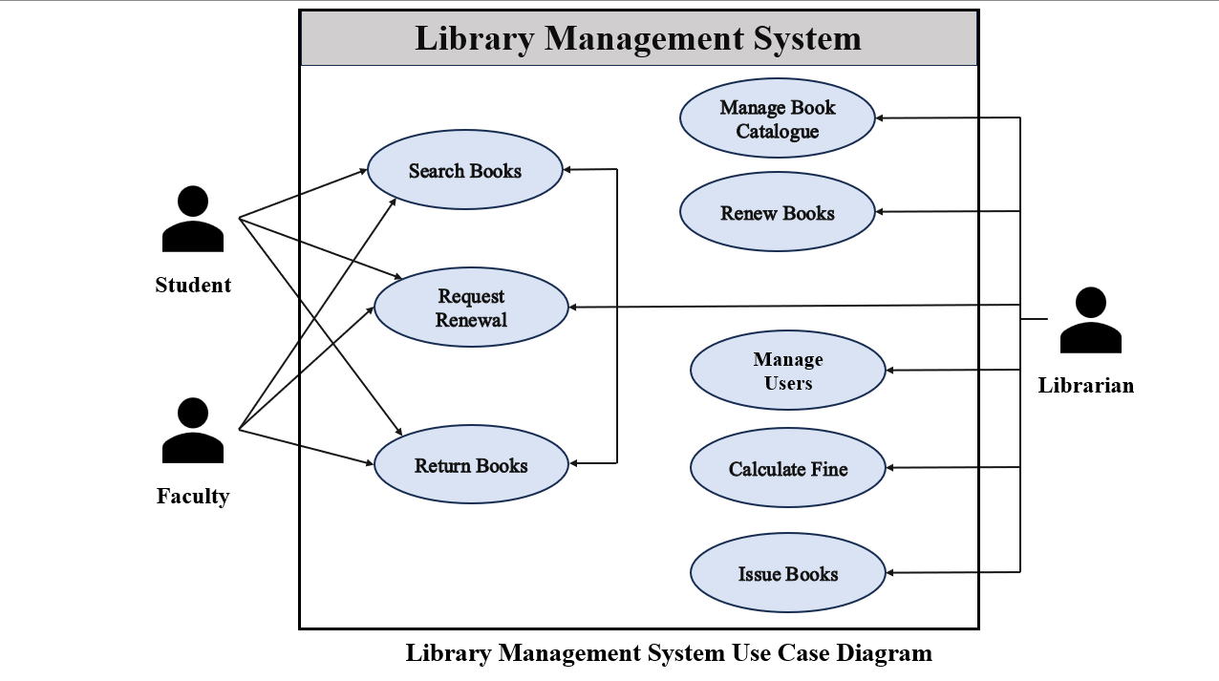
This diagram provides an overview of all possible actions users can perform, ensuring that each role’s access boundaries are clearly defined.
Figure 1: library management system use case diagram
- Activity Diagram
The Activity Diagram depicts the workflow of major operations, showing the sequence of actions and decision-making points. For example, in the Book Issue process, the steps include verifying user credentials, checking book availability, updating the database, and confirming the transaction.
It also represents parallel processes like fine calculation and book renewal. This diagram helps visualize the logical flow of control and enhances understanding of system behavior under different conditions.
- Sequence Diagram
The Sequence Diagram illustrates the dynamic interaction between system components in a time-sequenced manner. It shows how objects such as User Interface, System Controller, and Database communicate during a typical transaction — for example, when a user searches for or issues a book.
Messages flow from the user to the system interface, then to the database, and finally back to the user with results. This helps in understanding the order of operations and data exchange patterns.
- Class Diagram
The Class Diagram represents the static structure of the system by showing classes, their attributes, operations, and relationships. Key classes include:
- User (UserID, Name, Role, Email)
- Book (BookID, Title, Author, Genre, Status)
- Transaction (TransactionID, UserID, BookID, IssueDate, ReturnDate)
- Fine (FineID, Amount, Status)
Relationships such as association (between User and Book) and aggregation (between Transaction and Fine) define how these entities interact. This diagram ensures proper modularization and supports future scalability.
- Activity Diagram Description
The above Activity Diagram illustrates the dynamic workflow of the Library Management System, outlining the key activities performed by two main roles Librarian and Student/Faculty. It represents how different users interact with the system from login to logout, covering all essential library operations.
- For Librarian:
Manage Users: The librarian can add new users, update existing user information, or remove users from the system.
Manage Book Catalogue & Inventory: This activity allows the librarian to add, update, or delete book records to maintain an accurate and up-to-date catalog.
Search Books: The librarian can search for books based on title, author, or genre to assist users or verify inventory.
Issue Books: When a student or faculty requests a book, the librarian verifies availability, selects the member, and updates the inventory accordingly.
Renew/Return Books: During renewals or returns, the librarian updates the due date and adjusts the book’s availability status in the database.
Calculate & Collect Fines: If a book is returned after the due date, the system automatically calculates the fine based on the number of overdue days, and the librarian collects the payment.
Logout: The librarian safely exits the system after completing all operations.
- For Student/Faculty:
Search Books: Users can search the library catalog using various filters to find the desired books.
Request Book Issue/Renewal: Once a book is selected, users can send a request for issuing or renewing it.
View Borrowed Books & Due Dates: The system allows users to track the list of borrowed books and check due dates to avoid fines.
Pay Fines (if any): Users can view and pay fines online if they have overdue books.
Give Review/Suggestion: Users can provide feedback or suggestions for library improvements, ensuring user engagement and service enhancement.
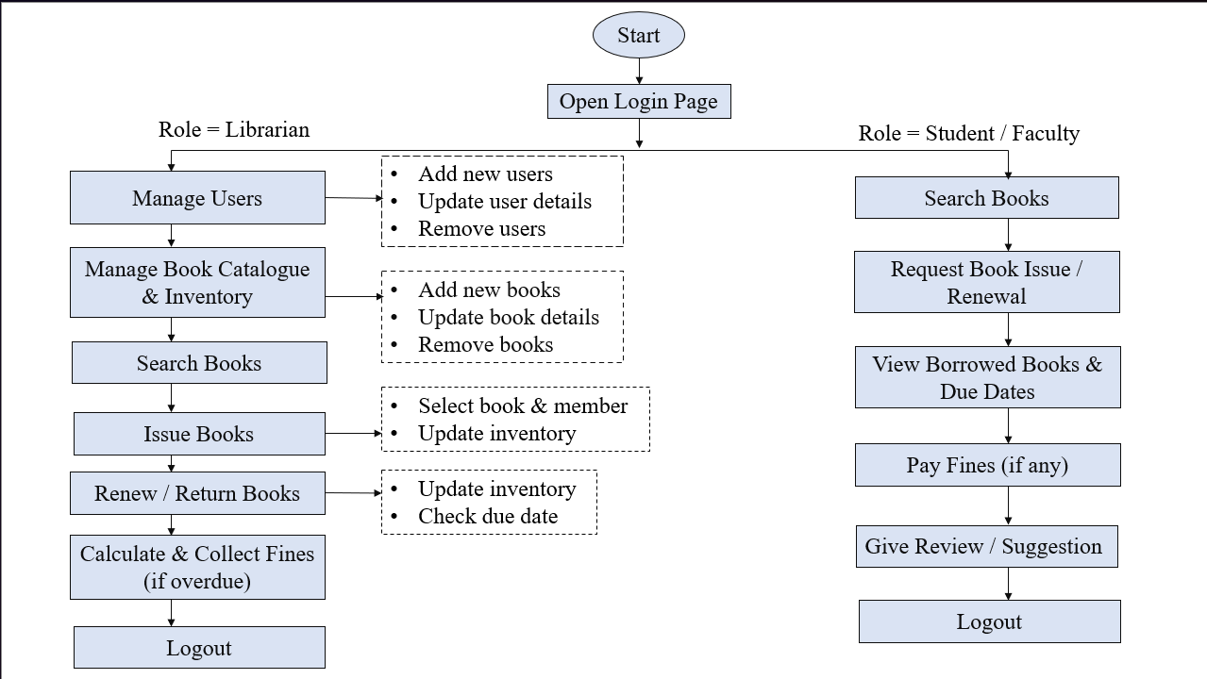
Logout: Finally, users log out to securely end their session.
Figure : Library management System Activity diagram

